**WSG**

* Login in to Mainframe using command **“ism”**
* Give your credentials.
* Choose the test region where you want to create the member ex:- **IMSW/IMSN**
* Give pause/break and **“/test mf”**
* For creating a WSG members GOTO profile **“memb05 ”**
* For Large groups to inquire a contract.

Choose option **“CU”** CUSTOMER SERVICES

Choose option **“FF”** BENEFITS & CONTRACTS

Give contract no and choose option **“AA”** GENERAL INFO.

* For creating a large group first we have to create a CASE then a GROUP and then we have to enroll the member inside that group.
* First take a sample CASE. To inquire a sample CASE.

Choose option **“AA”.** Give the case no and choose option **“CA”.**

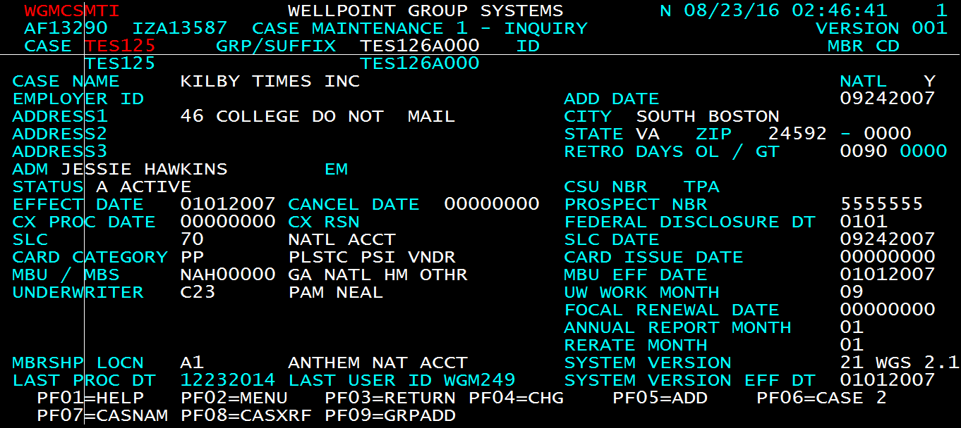

* To create a CASE choose option **“AA”** – CASE. Give a random case no and choose option “**CC”** - CASE 1. Copy paste the sample case only modify the below fields.

MBU – give the state and national or local

Effective Date – Give the current effective date

STATE – for which state you are creating members

**Press F10**

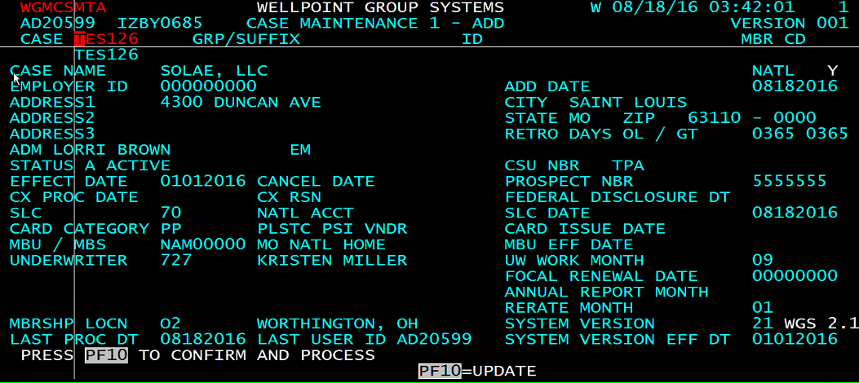

* In next screen give NON HMO ID CARDS field, CONTRACT STATE, FLEX BRAND = N and Press F10.

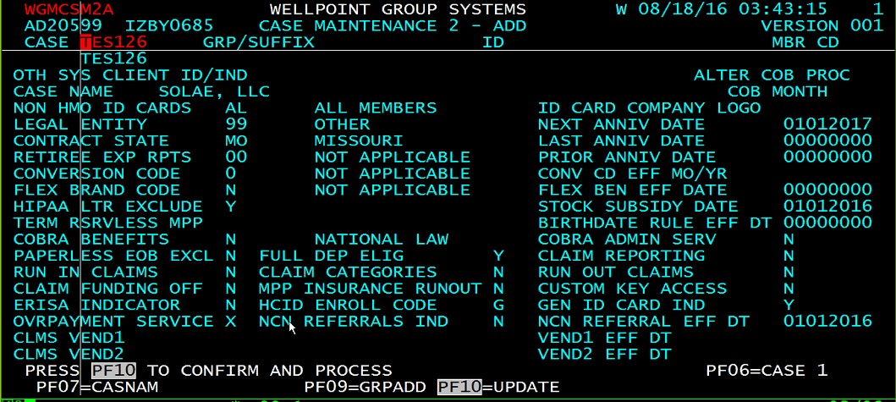

* Give below REP values in three screens and press F10.

REP# N000, 0277, 0155.

Case created. And if you inquire the case the status should be in ACTIVE.

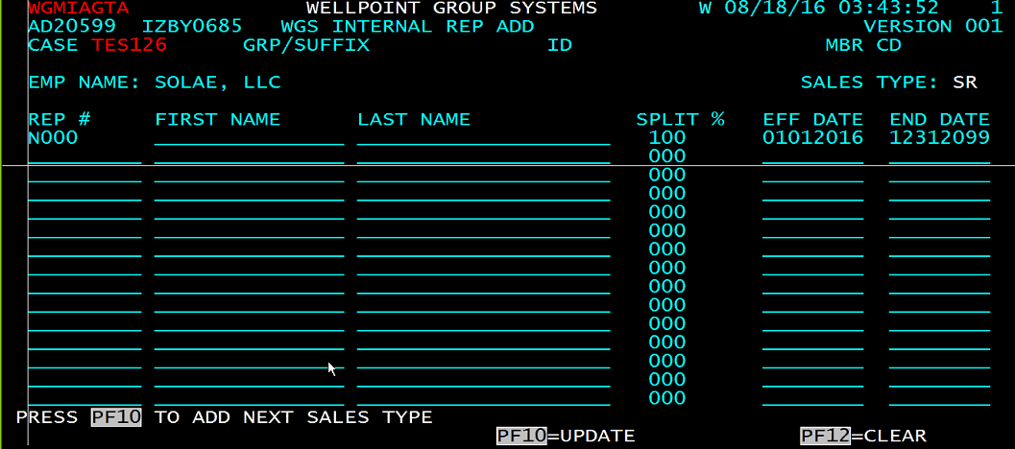

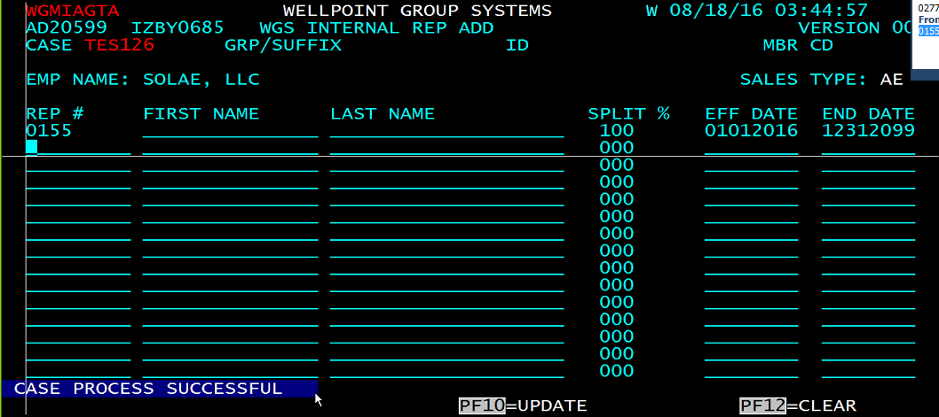

* How to create a group for the case. Inquire a sample group B1>GA.

Choose option **“B1”** – GROUP 1

Give the case no and random group id, if that group id is not present then Choose option **“AA”** - NEW GROUP.

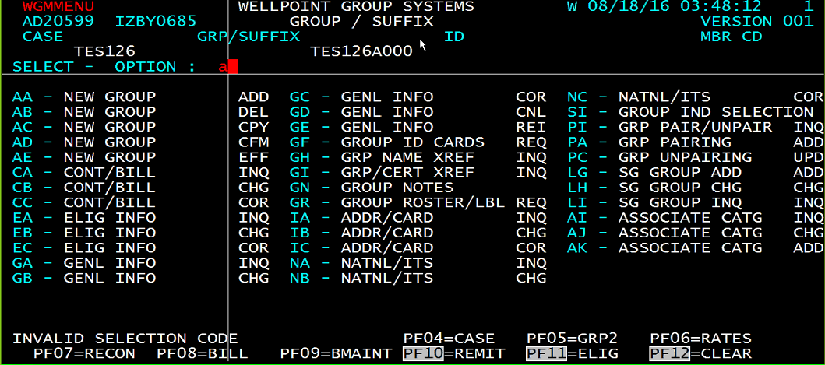

* Copy paste the sample group. Mandatory fields. Before creating a group verify the contract. The product line should also match with the contract. You can give the contract code in TSOA and get the sample group, just need to change the eff date first name and last name. only thing need to change is

**PRODUCT LINE**

**Effective date**

**Once everything is done. Press F10**

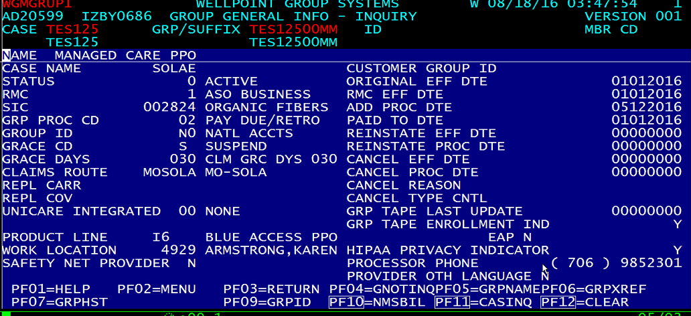

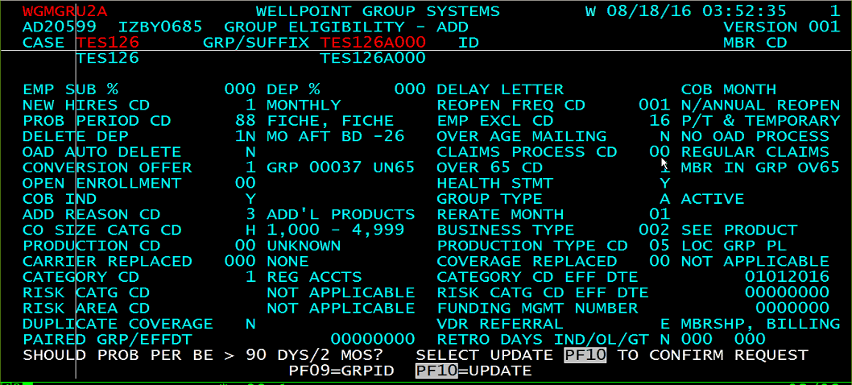

* Next screen take care of CLAIMS PROCCESS CODE it should be 0. Press F10

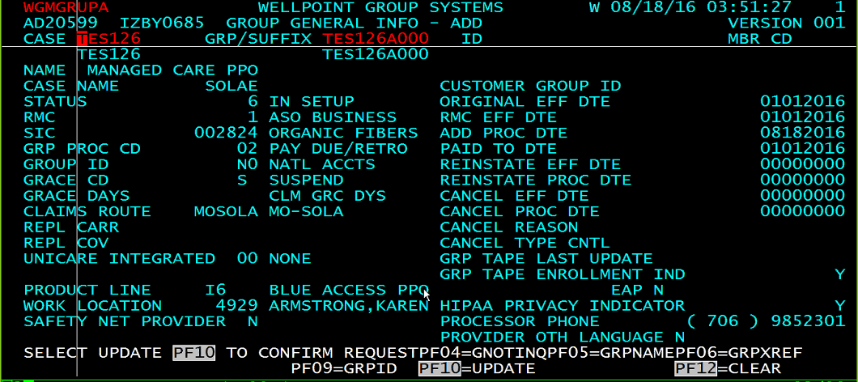

* Alpha prefix screen. Copy paste. Can change alpha prefix if required in this screen. Press F10

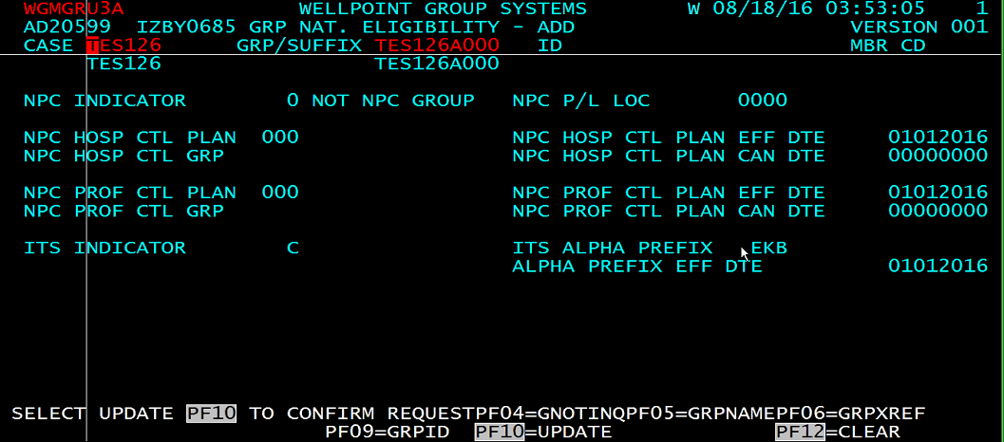

* Contract info screen. Update the contract but can’t change the product line. So before creating group check properly the product line and group are in sync or not. Press F10. Group process successful.

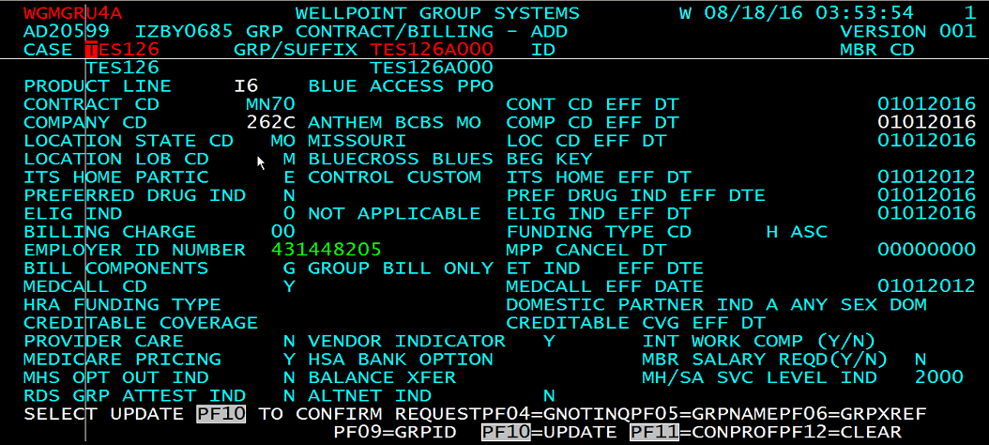

* Give enter and bill source screen will be shown. Here in this screen you can choose the BILL SOURCE whether it is premium bill or self-bill. Press F10

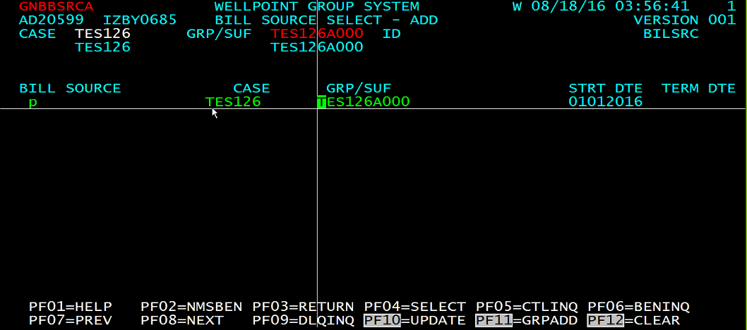

* Give G in entity and cycle code you have to select whether it will be monthly or whatever depends on when you want to generate the bills. Press F10

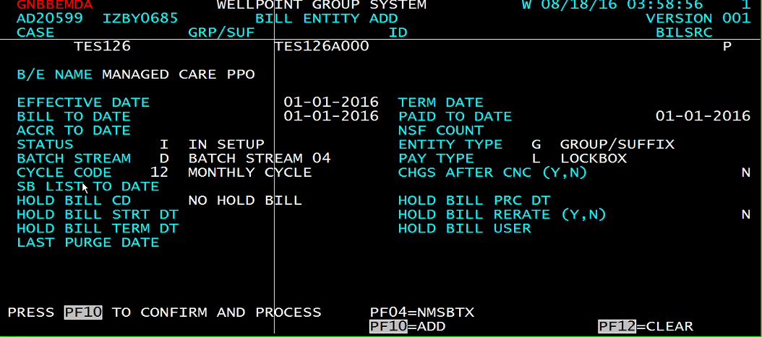

* Bill control info screen. To navigate the sample. Give F2 and PI in the below sample group screen. Then copy paste it. In this screen tolerance percent is mandatory field for premium bills. Press F10

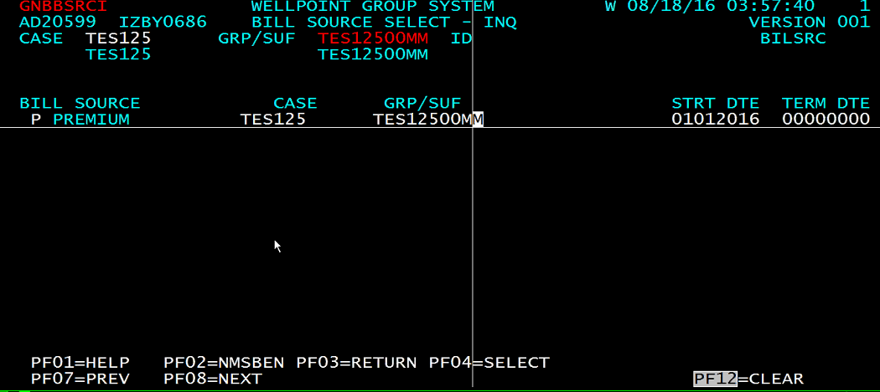

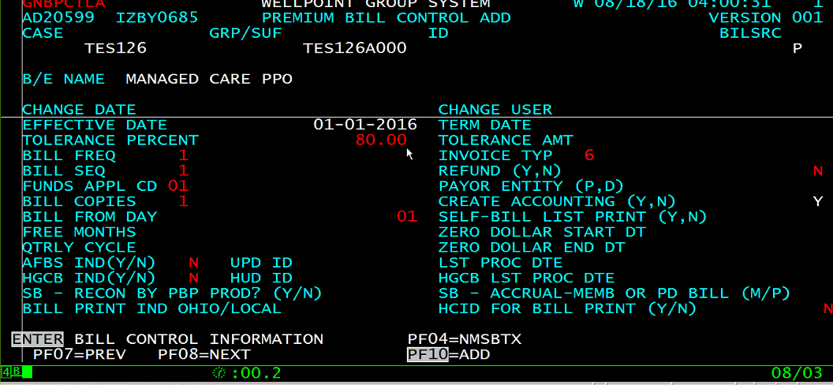

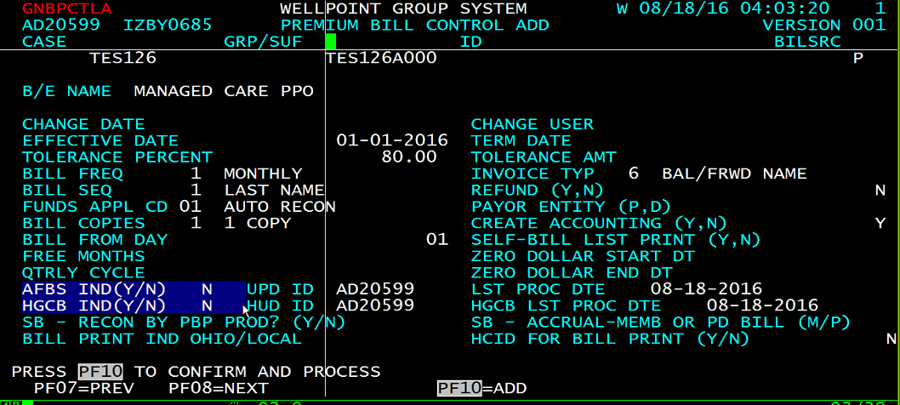

* Delinquency screen. In this give auto cancellation as N

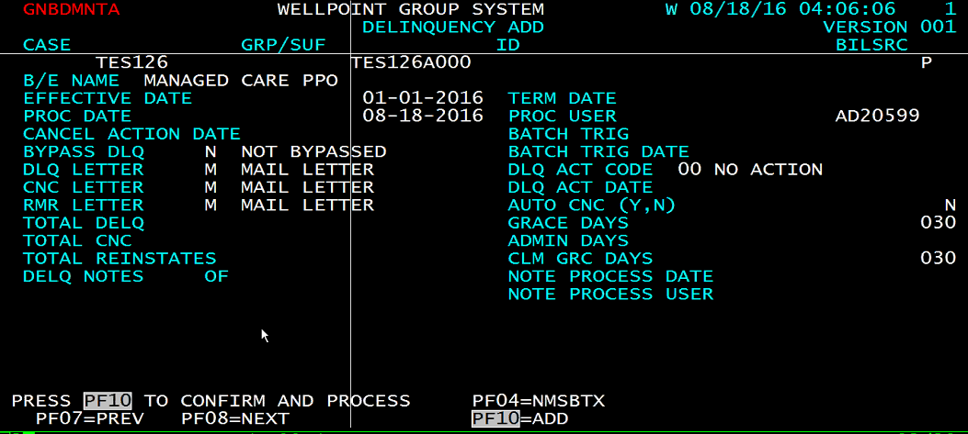

* Press enter and f10 till you reach this screen. Here you have to check for network id and paste that network id. To check network id give B2>NA.

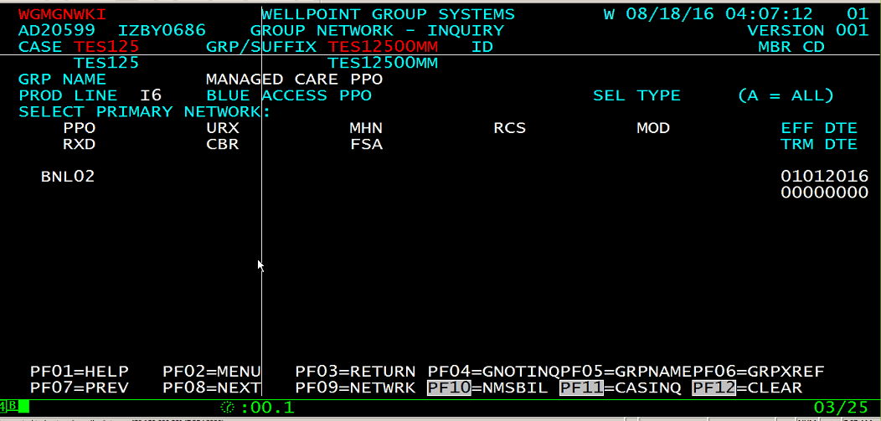

B2>na network id copy paste to above screen and press F10. To know more about network id press f9 and give network id.

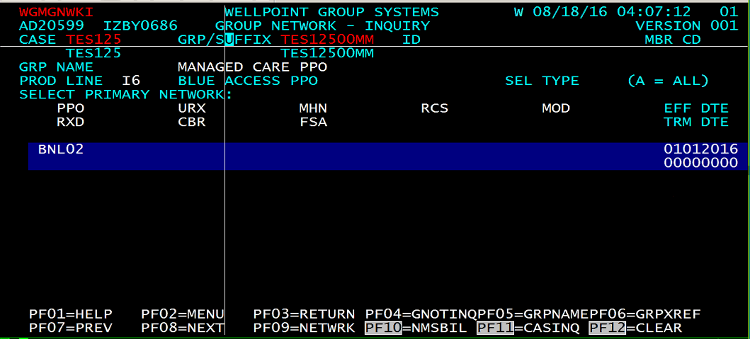

* Copy paste the screen from sample.

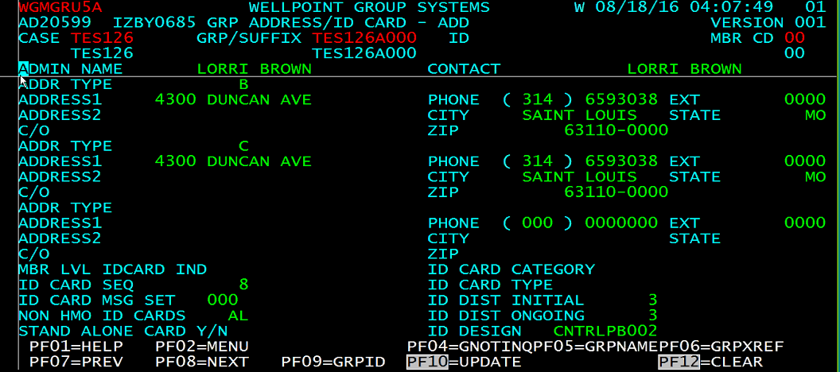

Press enter f10

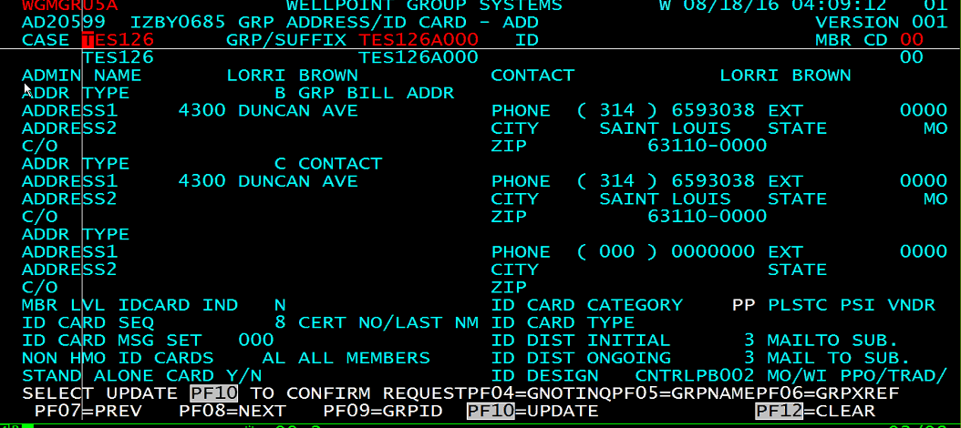

* Rate screen. Copy paste

Rate type **AB** is for only subscriber, you won’t be able to add dependent under it coz it does not have rate and so give **AF.** Give Rates A/B and C/D and totals and press F10

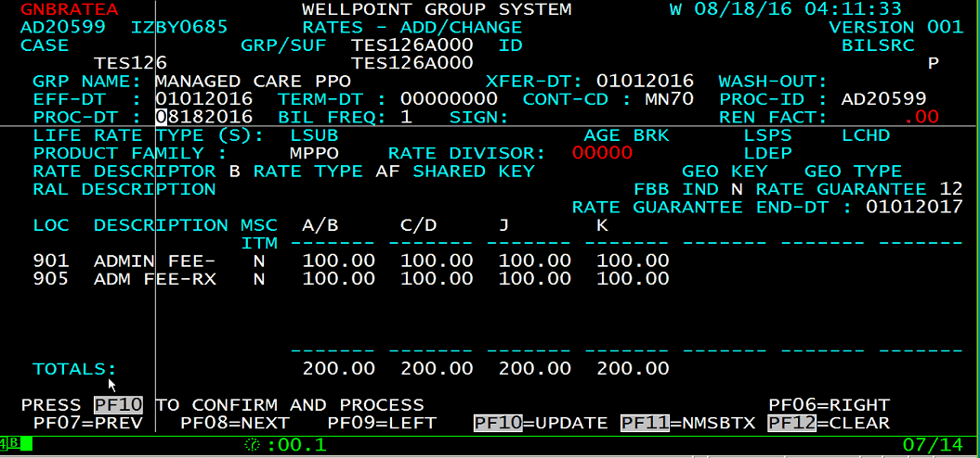

* Then inquire the group. If the STATUS of group is in IN SETUP then we need to confirm the group by changing the status from NEW or ACTIVE. Choose option **AD, enter and F10.** That means group is created.

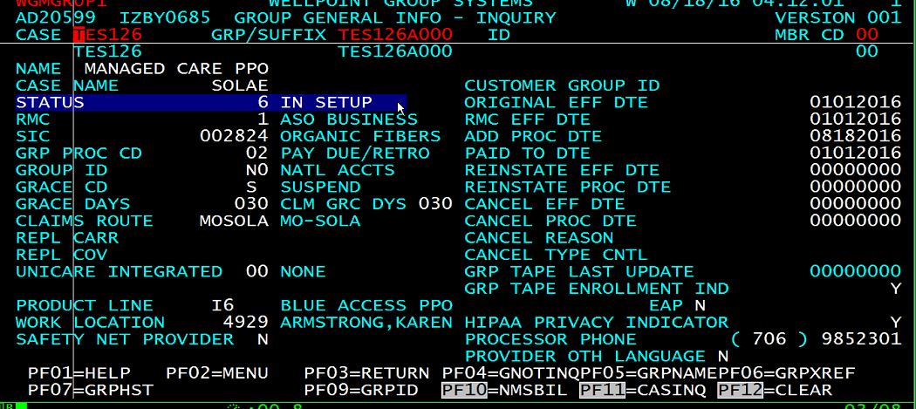

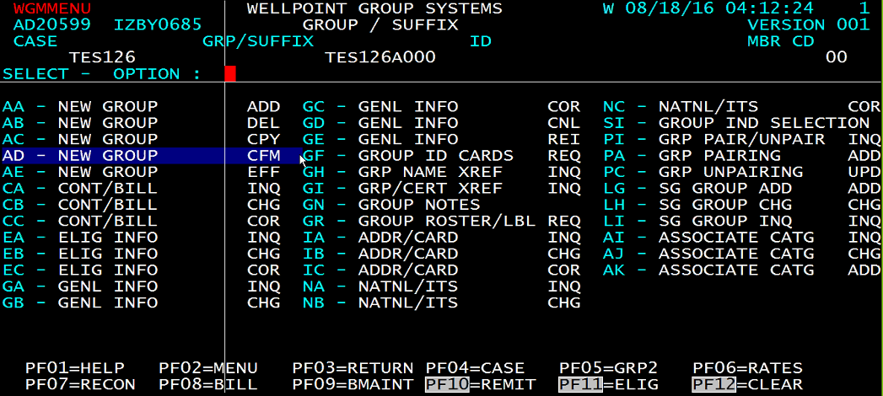

* **How to create a member**

Choose option **“C1” SUB/DEP MAINTENANCE**

In large group we have the option to generate the CERT Number (member id). Choose option **“NO”** - GENERATE CERT NBR.

To add the member GOTO option **AD – ADD (FAMILY/COV/MBR).** Fill the below details and if you don’t want to add any other member press F6.

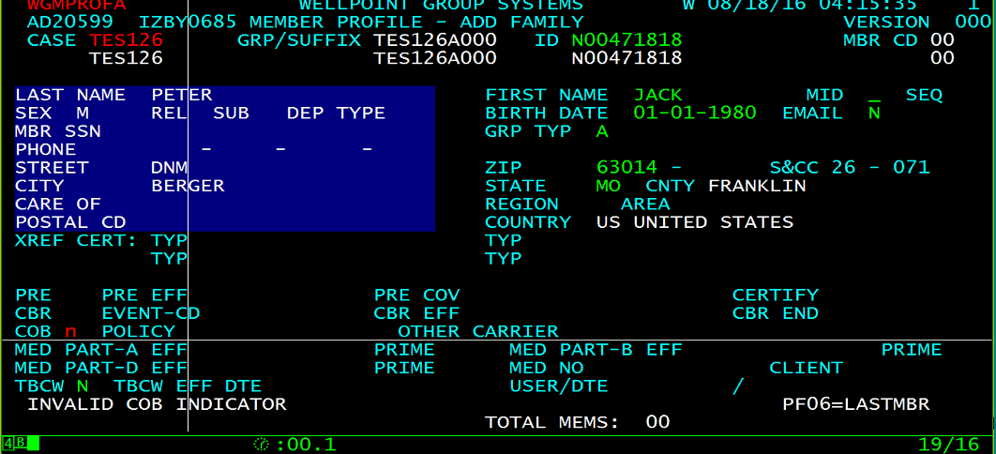

* Give the effective date and select the group under which you want to create a member. Press F10

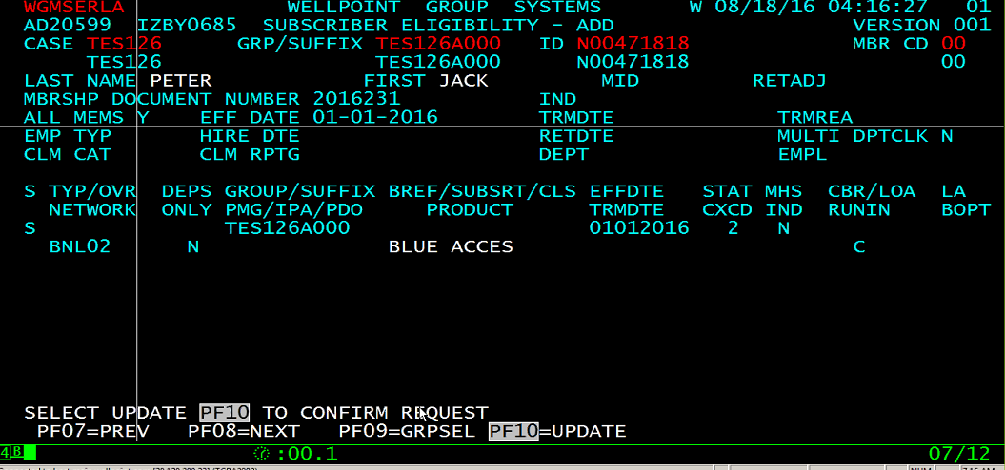

* Press F10. **Member process successful.**

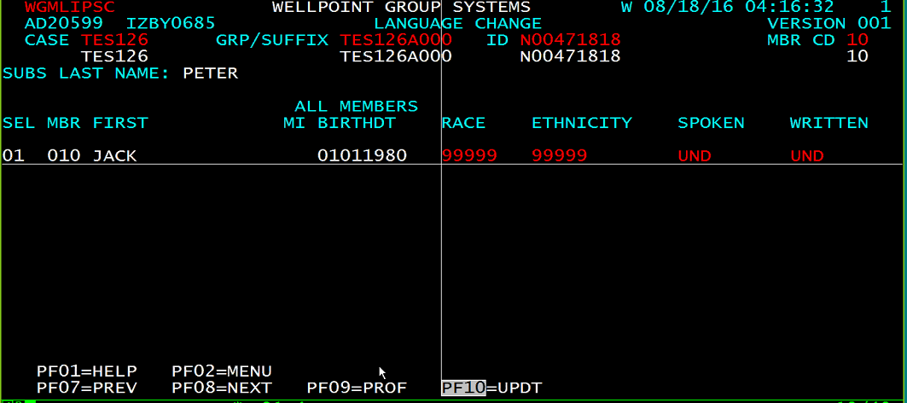

* **How to request Bill**
* GOTO option **B1** - GROUP 1 and F8 to request bill.

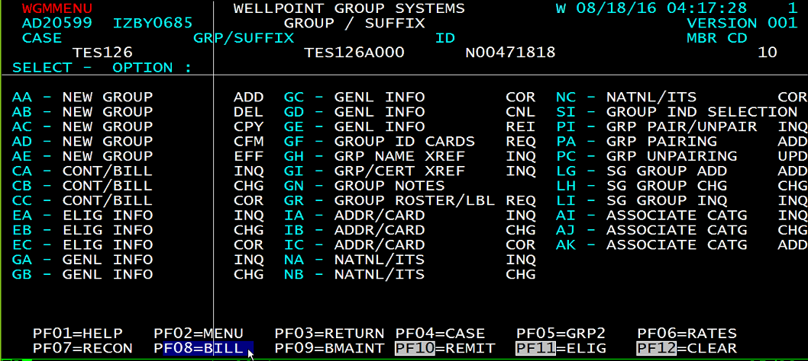

* Choose option “**PC** - BILL/RECON PROC/INQ” and the “**RB** - REQUEST BILLING”. 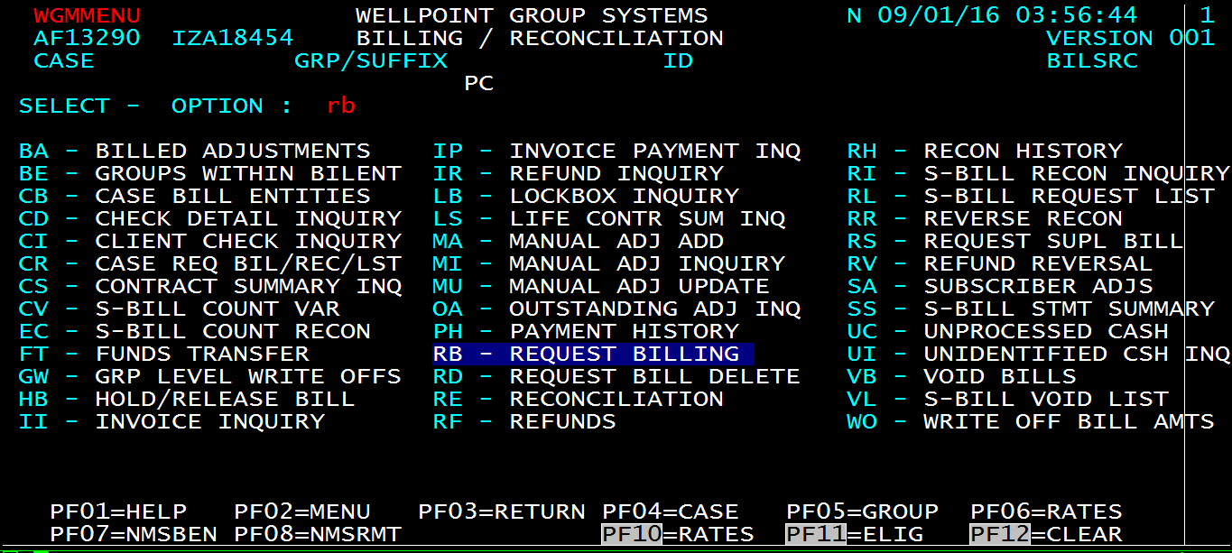
* If the status is in Setup then go back to option “**PA** - BILL ENT MAINT/INQ” and then choose “**TT** - BILL ENTITY ACTIVATE”. Give effective date and F10.

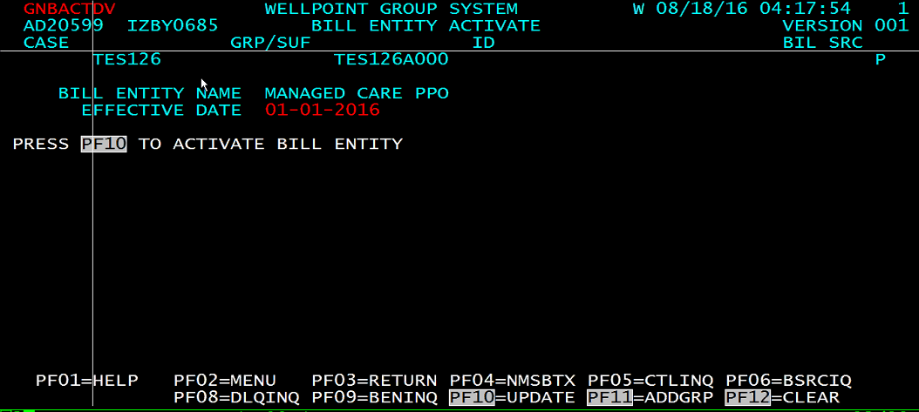

* Enter the no of months for which you want to request the bill and F10.

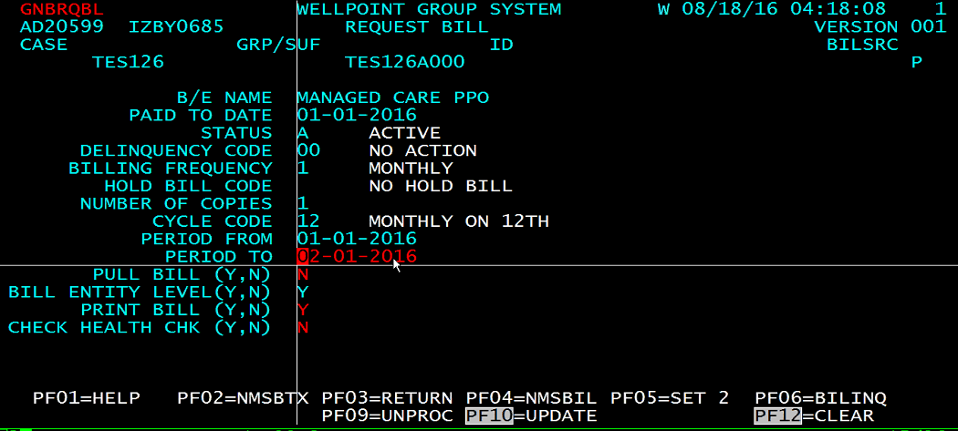

* It will take one day time to generate INVOICE for WSG. To inquire the invoice, choose option “**II** – BILLING”. Then choose option “**PC** - BILL/RECON PROC/INQ”. Under PC we have “**II** - INVOICE INQUIRY” choose that option to inquire the invoices.

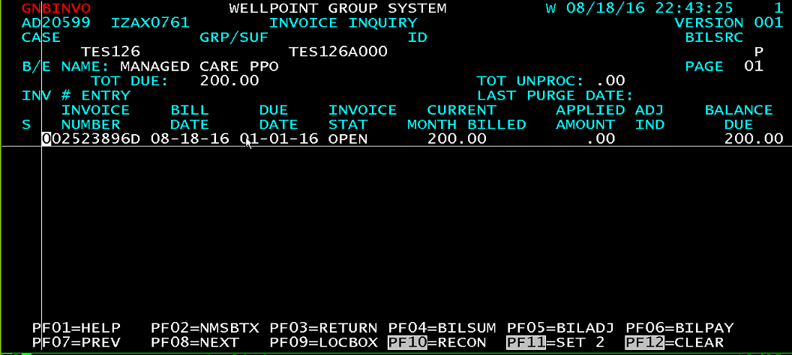

* How to recon the invoices.

To do reconciliation you need to go to one more profile **“nnsu01l”**

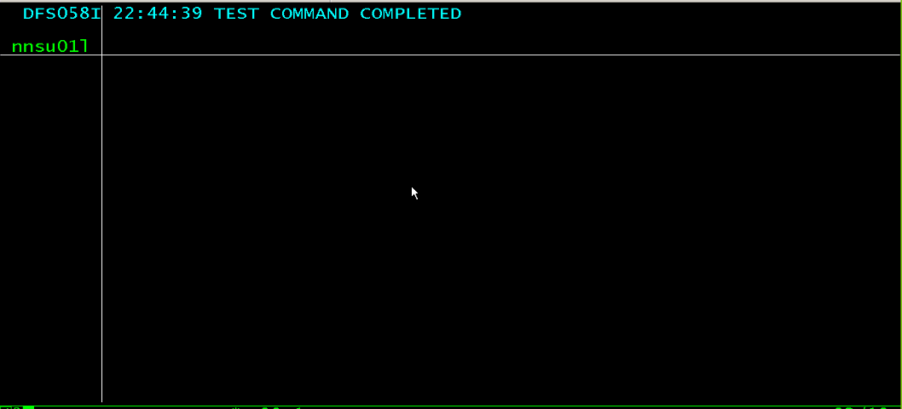

* Choose option “**HH** – BILLING” then choose “**BB** – BILLING” option again. Then choose option “**PB** - REMIT/CHECK HANDLING”

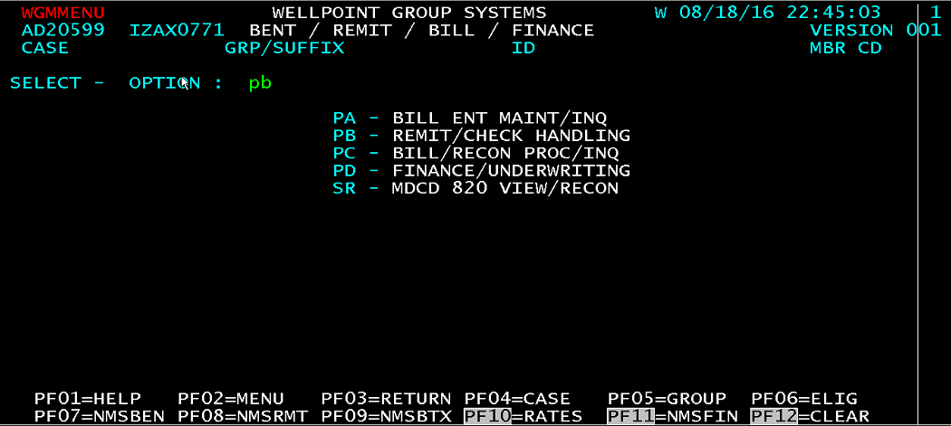

* Choose option “**RE** - REMITTANCE ENTRY”. Give the amount whatever you want to pay and group id, if you doing for only one group given “1 in ITEMS, give a random check no and F10.

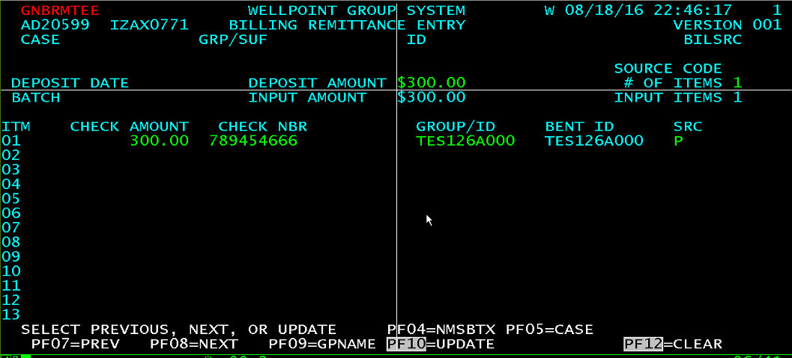

* Note down **the batch no** after pressing F10.

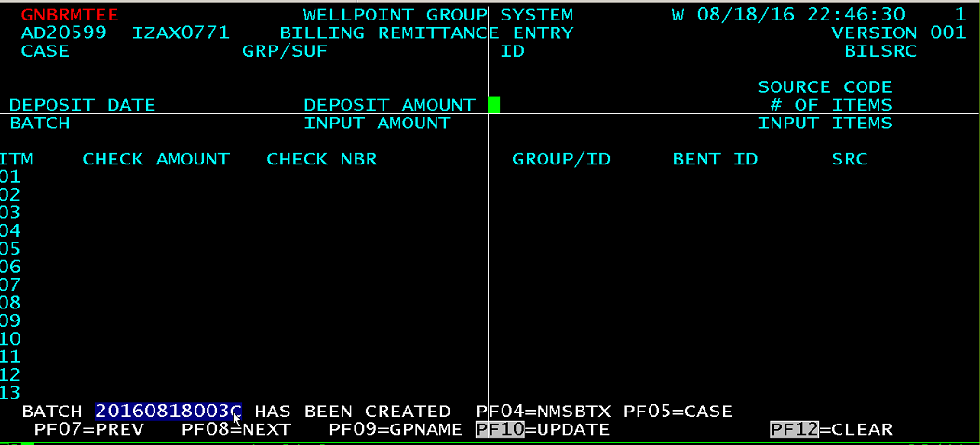

* After entry now go back and choose option “**RA** - REMITTANCE APPROVAL”. Give the batch no here it will automatically fetch all the details. F10 to approve.

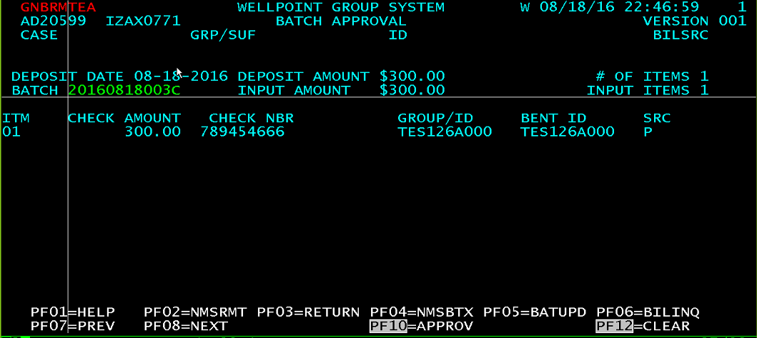

* Go back to the screen where we inquire the invoices in memb05 profile. To inquire the invoice, choose option “**II** – BILLING”. Then choose option “**PC** - BILL/RECON PROC/INQ”. Under PC we have “**II** - INVOICE INQUIRY”.
* If you are able to see the UNPROC cash then you need to reconcile press F10

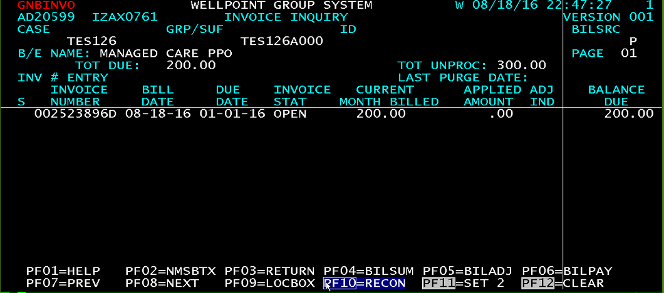

* Select the check no and press F10 to pay. Reconciliation done.

